For Senior Girl Scouts (9th & 10th grades)

For Ambassador Girl Scouts (For 11th & 12th grades)

Saturday, September 29th 2018
First United Methodist Church Social Hall
1400 Norwich st. Brunswick, Ga.
11am – 4pm
Register on or before September 21st to: Julie Lord (399-5065) Julielord71@gmail.com

Cost $20.00
Cost includes the following:
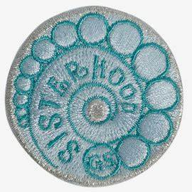
Journey Badge, program materials, Take Action project and snacks

