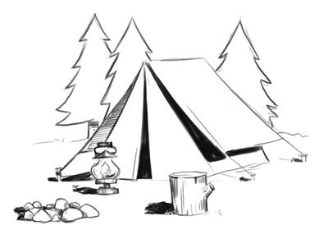

Outdoor Skills 101 (OS 101)
5:00 Friday night October 2 till 5:00 Saturday night October 3, 2020

If you EVER plan to have overnight activities with your Girl Scouts to any place that doesn't have connected bathrooms (like your back yard, a camp, etc) or you want to have camp fires for s'mores, etc., you MUST have taken this class. This is a basic class, not the advanced class. You may have fabulous outdoor skills, but you still MUST take this class since so much of the information is either :
- Safety considerations with Groups
- Organizational tips for you and the girls
- The Girl Scout Way
- The importance of girl training, preparation, and progression
- And HOW to teach the girls, (not how YOU have done it your whole life)
We try to hold the training at a time to give you time to train and plan outdoor activities with your girls. And WHY Friday afternoon? We begin setup at 5:00 on Friday afternoon, completing the course by same time Saturday, allowing you to still have one day of your weekend. (If you can't make it by 5:00, but can still make it by 7:00 or so, let us know and we will try to work with you-- We start early to have daylight to set up tents).
location: Emanuel United Methodist Church
245 Ratcliff Rd, Brunswick, GA 31523

Cost $20
Minimum-5 participants; Maximum- 8
Deadline to Register: Monday, September 28, 2020

Due to COVID-19 concerns, each camper must have their own sleeping area (tent). The Service Unit has several small tents, so if you need to borrow one of those, it will have to be on a first-registered basis. If you plan on bringing your OWN or have an extra, please let me know.
IMPORTANT: GSHG Subject Matter video(s) with knowledge check is a Pre-requisite for participating in Outdoor Skills 101

Questions?- Laura Pittman (stelaupit@gmail.com) or Margaret Laurens (jcharles195@comcast.net)

Register through Laura Pittman at stelaupit@gmail.com
(Put OS101 in the Subject Line & I will send the WuFu form)

