Girl Scout Junior “Get Moving” Journey

- Intro Activity - Have video from Animal Atlas http://www.animalatlas.tv/ playing as girls arrive (opening activity optional)
  - Provide sheet with questions girls can answer while watching animals (see page 2/3)
- Stop Video when time to start and briefly discuss animal energy. Explain that energy is all around – inside each of us, places and spaces -- getting here from there -- it’s everywhere.
So that’s what we want to focus on during today’s journey “Get Moving”
- Have the girls lead the Pledge, Promise, Law (Will draw to see who leads)
- Cover Energy and Recyclables (provides an idea to the girls what the journey is all about)
  - Go over types of Energy (have copies of pages 10/11)
  - Page 20 – My Energy Pledge
  - Page 33 - Recyclables
  - Page 41-43 examples of recyclable bags, dresses
- ROTATION STATIONS – Give each girl a check off sheet to confirm finished stations)
RECYCLE STATION
  - Make Recyclable paper (See page 36-38 in Girl’s book) or use recyclable recipe from another source. We used cut up paper, blender, plastic basin (bowl) warm water, screen pot lid for the seve. Best to find a YouTube example that you like to see how to make. Let the paper dry. In our case until the next meeting. We place on a paper plate to dry.
  - Recycle – Beans for necklaces or make spider (see page 4)
INSULATION STATION
  - Insulator Station (see Page 5 in Girls Book and Page 5 and page 6 in this file – print out slip for each girl )
ENERGY – LIGHT BULB STATION
  - Light Bulb Station -- Make it self-serve – have information and questions ready. (see Page 7-9) Page 9 is the sheet for the girls to complete.
DRAFT CHECKERS
  - Draft Checkers – Make from Popsicle sticks and plastic wrap. (See page 10 and 11 this file)
SILHOUETTE STATION – TAKE ACTION
  - Silhouettes -- Need to have paper cut ready to tape on wall (have roll paper already). Have projector ready or light can use to shine in making a silhouette. Pair the girls to draw each other – use energy of the mind and body to make creation
  - If have time set up “freeze dance” station – girls energy here (game – play freeze)
- Energy Snack (Give out Home Audit to take home for girls to check – Page 12)
- Closing – give out “Get Moving” badge set
- Supply list

“Get Moving”
Page 2
How do Animals Use Energy?
- ____________ 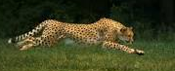
- ____________ 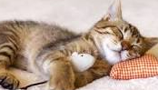
- ____________ 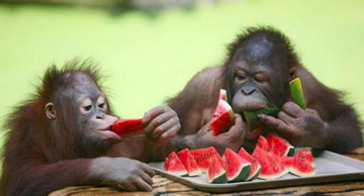
- ____________ 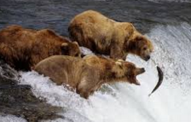
- ____________ (your ideas)

“Get Moving”
Page 3
Draw an Animal Use Energy

Or
Write a poem about an animal using energy:

Our troop made recycled paper beads for bracelets. It was a good, but the girls lost focus shortly, so a good idea would be to make the spider.
Page 4

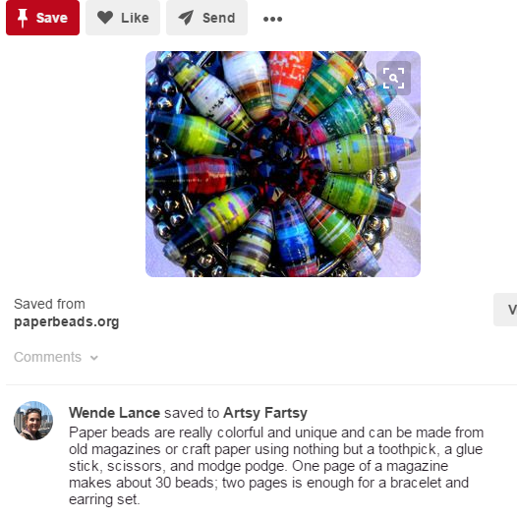
On page 8 of the girl’s book is an introduction to the spider
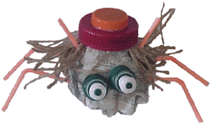
Bottle caps, straws, and newspaper to create their very own Litter Spider.
DIRECTIONS:
Crumble up a piece of newspaper. Wrap another piece around it. Wrap with string and tie off to hold newspaper in a ball. Add straws, bottle tops, caps and anything else to make it look like a litter spider.

Page 5
INSULATION STATION
- Insulation improves the use of energy in a building because it keeps heat inside in the winter and air conditioning inside in the summer.
- Guide the girls through an examination of the various insulation materials where they will select to wrap their jar.
- Ask girls which insulation will they predict works best.
  - Supplies:
    - Mason jar for each girl (Adult fill with hot water after insulator added)
    - Thermometers
    - Insulators
      - Socks
      - Paper
      - T-Shirt Jeans
      - Nothing
    - Record Temperatures (see page 6 for form). Can set a timer for 15 min between 2 or 3 checks. Depends on how many girls.
    - Discuss which insulators works best based on temperatures from each girl.

Insulation Name:_____________________
Page 6

Insulation Around Jar – Circle one | Starting Temperature | Temperature  #2 | Temperature  #3 | Difference between  starting and #3
T-Shirt Sock Paper

Insulation Name:______________ ______

Insulation Around Jar – Circle one | Starting Temperature | Temperature  #2 | Temperature  #3 | Difference between  starting and #3
T-Shirt Sock Paper

Insulation Name:__________ ______

Insulation Around Jar – Circle one | Starting Temperature | Temperature  #2 | Temperature  #3 | Difference between  starting and #3
T-Shirt Sock Paper

Insulation Name:______________ ________

Insulation Around Jar – Circle one | Starting Temperature | Temperature  #2 | Temperature  #3 | Difference between  starting and #3
T-Shirt Sock Paper

Page 7

Information About Light Bulbs for Kids
Can you imagine having to live and work in the dark? Before the invention of the light bulb, people used a variety of different ways to light their way at night. Wax candles and lamps that burned oil and kerosene were common, but they were dirty and risky to use because they created flames to make light. All that changed in 1879 when Thomas Edison perfected a practical electric light bulb that was both bright and safe. Light bulbs make our lives easier.

Parts of a Light Bulb
A light bulb has three main parts: a metal base that conducts electricity, a thin wire called a filament and a glass bulb that surrounds and protects the filament. The bulb protects the filament by keeping air away from it.

How It Works
When a bulb is screwed into an electrical socket, it creates a circuit, or loop, which allows electricity to flow into the bulb and through the filament. The filament is made of a metal called tungsten that doesn’t let the electricity flow very easily, creating what is known as electrical resistance.

What Makes the Light?
When the electricity pushes its way through the filament, the filament heats up and gets so hot that it begins to glow. The filament glows brightly enough to create light.

Brightness
Some light bulbs are brighter than others depending on how much resistance the tungsten filament provides. You can tell how bright a light bulb is going to be because it has a number rating, expressed in watts. (Watts are a measure of energy used and are named after inventor James Watt.) The higher the number of watts, the more electricity the bulb uses and the brighter the light will be.

New Kinds of Light Bulbs
One problem with these light bulbs is that they aren’t as efficient as they could be, which means that they use a lot of electricity compared to the amount of light they produce. To solve this problem, light bulb manufacturers now make light bulbs called compact fluorescent lights, or CFLs. CFLs are more efficient because instead of pushing electricity through a wire, they allow the electricity to flow through a glass tube and light up a combination gas and chemicals called argon and phosphor.

Light Bulb Safety
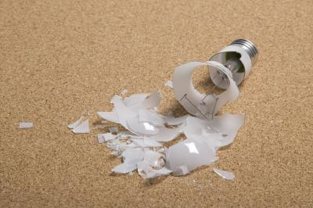
Modern light bulbs and CFLs are safer than the old candles and lamps they replaced, but they still need to be handled carefully. If a regular light bulb breaks there will be sharp glass that needs to be cleaned up. It can be even more dangerous if a CFL breaks, though, because the chemicals inside are poisonous, especially a a liquid metal called mercury. If one does break, stay away until an adult cleans it up.
TYPES OF LIGHTBULBS
Page 8
Features |  |  |  |  |  |  | 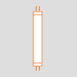
 | Incandescent |  | CFL | LED |  | Halogen | Fluorescent
Rated Avg. Life | 755-1000 |  | 10,000 | 45,000 |  | 3,000 | 3,000
Life Span | Low |  | Long | Very Long |  | Medium | Medium
Watts | 3 - 500 |  | 3 - 120 | 2.5 - 16 |  | 5 - 500 | 5 - 500
Cost to Operate | High | Low |  |  | Low | Medium | Medium
 | Most common  Least Expensive  Warm, inviting quality  Used with dinner  Not energy efficient | Easy way to adopt energy saving practices in the home.  Consume a quarter of the energy that incandescent bulbs do and last 10 times longer.  Are quiet, instant-on and have warmer, color-corrected tones.  They can be used anywhere you would use a typical incandescent light bulb. Contain trace amounts of mercury, a harmful substance. Although the bulbs contain far less mercury than other household items, care needs to be taken to prevent breakage. Also, when CFLs burn out, they should be recycled. |  |  | LED, which stands for "light-emitting diode," is a lighting technology that is long-lasting and extremely energy-efficient, but they're not ready to supplant all other bulbs yet. For one, they provide only directional light, not diffused light, making them ideal for under-counter task lighting, but not general room illumination. To overcome this, new models consist of large arrays of LEDs clustered together, but at prices from five to six times higher than CFLs, the bulbs are not for everybody. | Bright & lasts twice as long as standard bulbs.  White light – closes to natural light  More energy efficient than Incadescent.  More expensive  Burn at a higher temperature  Used under cabinet lighting and recessed lighting.  Don’t use bare hands to change halogen bulbs. The smallest residue of oil from a human hand can rub off on the bulb, creating an atmosphere where the bulb warms too quickly when the lamp is turned on, which can cause the bulb to explode. | Common  The typical fluorescent gives a flat, cold light, often bluish and harsh. It is a daylight-equivalent and cannot be put on a dimmer. There are many types of fluorescents on the market: warm ones, cool ones and special-colored ones, and they typically produce more light and last longer than incandescent. Fluorescent bulbs work well to light large areas like basements or attics.

Page 9

Get Moving – Energy “Light Bulbs”

- 23 Watt CFL (Compact Fluorescent Light)
- 60 Watt Incandescent
- 100 Watt Incandescent

Which Light puts off the most light?
A B C

Which Light puts off the most heat?
A B C

Is the hottest bulb the brightest ?
Yes No

Which Bulb to you think is most energy efficient?
- 23 Watt CFL (Compact Fluorescent Light)
- 60 Watt Incandescent
- 100 Watt Incandescent

Page 10
Draft Station – DRAFT CHECKER
- Do you know what a draft is?
  - Air moving into or out of a building in a place where it’s not wanted, such as around a window, door or electrical outlet.
- Energy is being wasted because it’s escaping from the door or windows.
- Make a draft tool
  - Pencil or popsicle stick
  - Cut a 6 x 12 piece of plastic wrap
  - Tape one short edge of the plastic to the popsicle stick letting the rest hang free.
- Move about the room looking for places that may feel drafty
- Brainstorm what to do about it.
- Take draft tool home and use to check for drafts.

Page 11

Check for Drafts NAME__________________________
Location | No Draft | Small Draft | Medium Draft | Got a Problem Draft!

Check for Drafts NAME__________________________
Location | No Draft | Small Draft | Medium Draft | Got a Problem Draft!

Check for Drafts NAME__________________________
Location | No Draft | Small Draft | Medium Draft | Got a Problem Draft!

Page 12
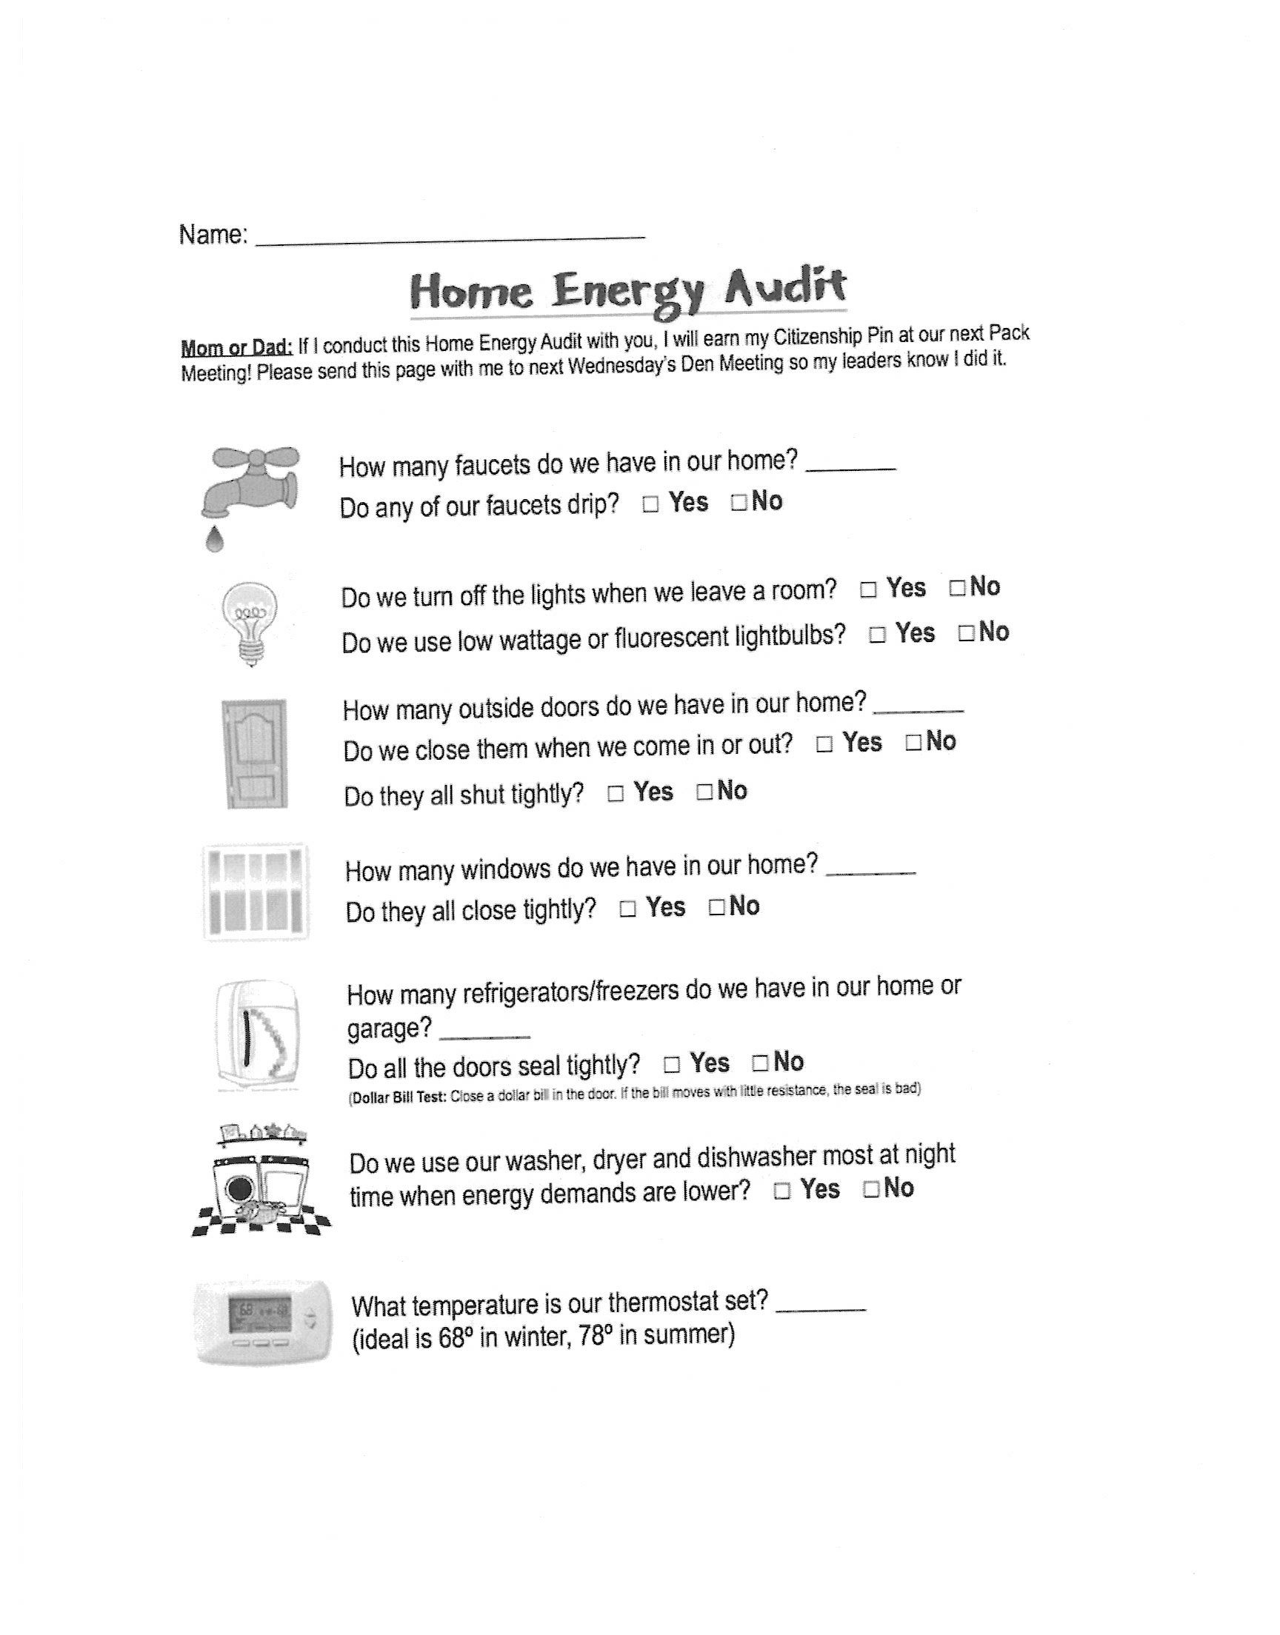

Junior Girl Scout – “Get Moving” Journey
SUPPLY LIST
- Folder for each girl to keep take home information
- Optional – have video playing – animal energy
- Copy (handouts)- pages 2, 3
- Recycle Station
  - Paper cut up in pieces
  - Plastic basin
  - Blender
  - Warm water
  - Screen pot lid for seve
  - Paper towels
  - Paper plates – let paper dry
- Insulation Station
  - Copy Insulation slip for each girl (page 6)
  - Mason jar per girl
  - Thermometers (candy thermometers work best) – may need to share
  - Hot water
  - Socks
  - Paper
  - T-shirt
- Light Bulb Station
  - Tri-Fold poster works good to divide the table – light in each section
  - Have page 7-8 on display
  - Copy page 9 for each girl
  - Need 23 watt CFL lamp, 60 watt and 100 watt
- Draft Checker station
  - Popsicle Stick or pencil
  - Plastic wrap
  - Tape
  - Copy page 11 (one slip for each girl)
- Silhouette Station
  - White paper on roll works well
  - Tape
  - Markers to draw outline of each girl
  - Decorate silhouettes – we used scrap book paper with lots of colors

