Girl Scouts Junior Journey – aMUSE

SUPPLY LIST

“REACH OUT”
- Print sheet – definition of stereotype (driver, donut and potato example)
  - Discuss list of Sterotypes
- Post it notes /markers (prepare roles in advance)
- Paper Dolls – Michaels has them
  - Material scraps, yarn for hair
  - Glue
  - Scissors
  - Markers to draw face
- Canvas Art
  - Canvas – Found at Michaels (comes in packs of 5 or more)
  - Mod Podge
  - Magazines (variety – not all cooking) try to have sports, career type, animals, exercise, variety of careers if possible)
  - Painted canvas in advance to let dry – girls decorated with topic selected – breaking Sterotypes of “can’t do this, because . . . “

“SPEAK OUT”
- Yarn (any color) – 1 roll yarn per group (amount depends on number of groups)
- Story card game
- Story rocks (if you’ve made previously or could make in this journey)
- Prop Box – put fun items to role play

“TRY OUT” – Only need supplies from Prop Box

Junior Journey – aMUSE

- 9:30am – 10:00am
  - Sign In
  - Pick up folder for the day
- 10:00am -10:15am - Openingl
  - Cadettes lead Juniors with song
  - Welcome
  - Promise & Law
- 10:15am - 11:00am -- Jr Journey – aMUSE
  - All girls sit together for this session in U-shape
  - Explain purpose of Journey (Review pages 4,5, 9 from girl’s book)
    - “Reach Out” to explore roles”
    - “Speak Out” against Stereotyping roles that could hold you back and tell a story
    - “Try Out” a new role – inspire others with your story
    - “Reach Out”
      - Flurry of Roles - Use Sticky notes and complete activity (see page 4/5)
      - Define Stereotyping (discuss examples as appropriate) (Page 6/7/8)
        - to believe unfairly that all people or things with a particular characteristic are the same (Discuss Stereotype examples)
      - Paper Dolls/My Roles – all dolls look the same but we’re different—decorate and put on wall (page 9)
      - Canvas art (use magazines pics) – Page 10

- 11:00am –12:00Nn– “Speak Out” - “Prop Box” & “Take the Stage”
  - 4th and 5th grade Separate if necessary
  - Breathing Exercise (page 11)
  - “A Good Yarn" Storytelling Skills – Hand out story cards and explain yarn (see attached for activity). (Page 12)
  - Role Playing – Page 13/14
    - One team at a time or individuals will select from prop box and act out role. Girls will guess who/what they are. Ok if only have a couple willing to role play.
      - Select from prop box – hat, scarf, flowers, jewelry, fun glasses, mask, etc.)
- 12:00n – 12:30pm – break for lunch
- 12:30pm – 1:30pm – “Try Out” - Separate groups – 4th and 5th grade
  - Practice Stereotype busting story to perform in front of full group. Performance will be the “take action” project. All the girls need to participate in the final story.
- 1:30pm – 2:00pm – Closing – journey badge set
Explain Purpose of Journey
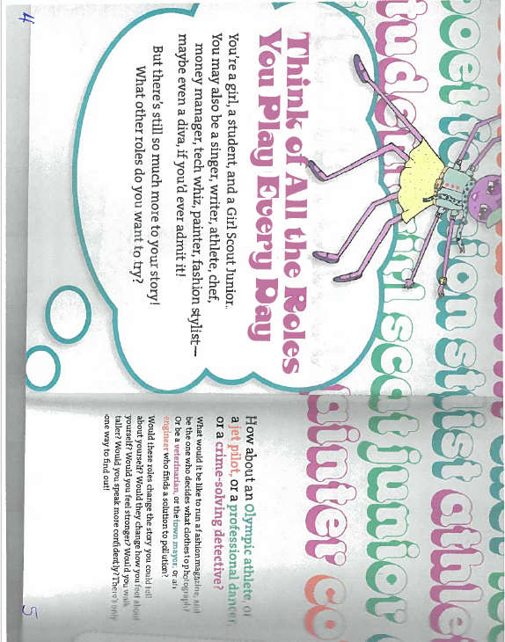
Page 3

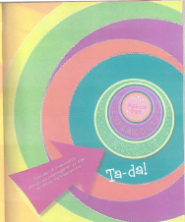 Page 9 in Girl’s book
“Reach Out”
“Speak Out”
“Try Out”
“Reach Out”
Page 4
“Flurry of Roles”
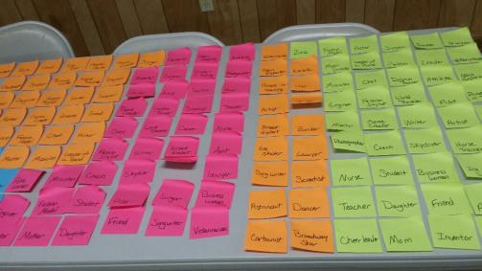
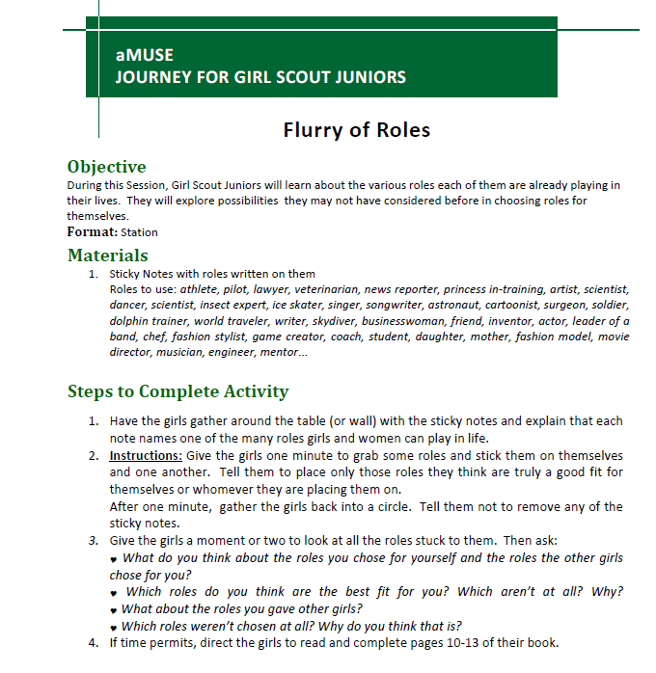

Page 5

Select FIVE favorite girl characters
(Use with Flurry of Roles)

1._____________________

2._____________________

3._____________________

4._____________________

5._____________________

Page 6
“Reach Out”
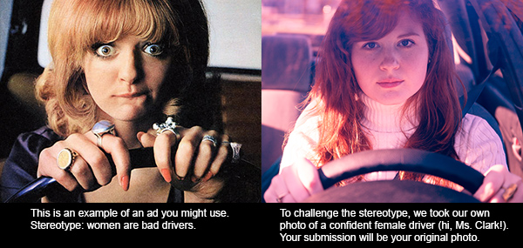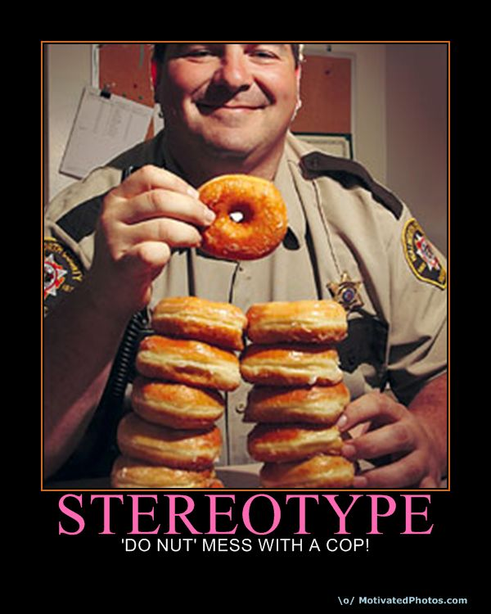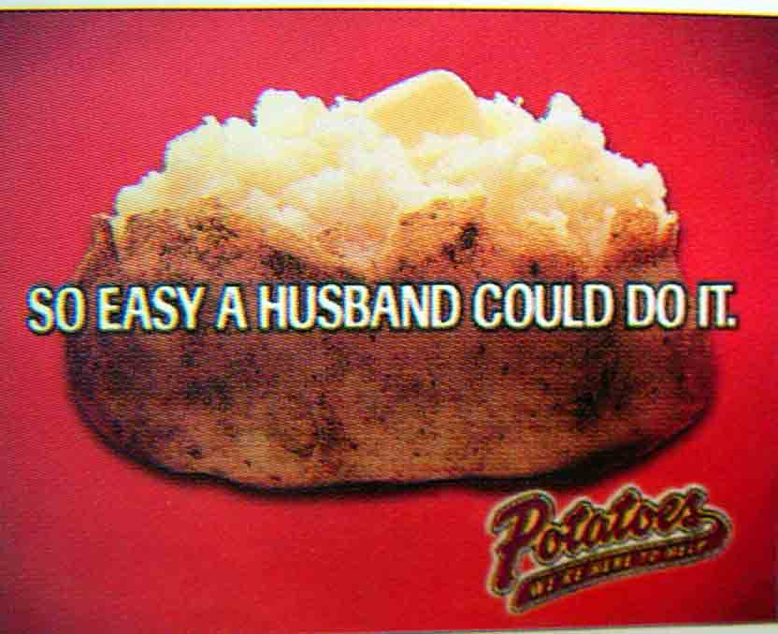
All husbands can’t cook
All police officers eat donuts
Definition of Stereotype
ster·e·o·type
noun
- a widely held but fixed image or idea of a particular type of person or thing.
- Making judgments about people without knowing them
- Making assumptions without understanding a subject

“Reach Out”
Page 7

Stereotypes Examples (for discussion – may not want to use all – do not offend ethnic backgrounds in your troop)
Whenever we don't have a good understanding of a subject, say, of people or countries, then we tend to make assumptions about them. Stereotype is nothing but those assumptions that have become common knowledge. Whenever you make judgments about people without knowing them, you are stereotyping them. Stereotyping makes people generalize things. More often, they are all false assumptions. Though there are both positive and negative stereotypes, a majority of them are offensive. People generally stereotype out of bias against a particular group of people or religion. Stereotyping becomes a way of conveying their dislike. Of course, stereotyping stems from a commonly held view of a particular group or race. This view may arise from an incident or false assumption, and then maybe used to color the entire community with the same brush. There are various types of stereotypes. However, the most common ones are racial stereotypes and gender stereotypes. Race, nationality, gender and sexual orientation are the main factors of stereotyping. Stereotyping must be avoided at all costs, as it leads to treating groups as a single entity. Given below are examples of stereotypes that people commonly use.
Examples Of Stereotypes
Negative Stereotypes
- All blonde women are dumb.
- All red heads have a temper
- [f I wear Goth clothing I'm a part of a rock band, depressed, or do drugs.
- Girls are only concerned about physical appearance.
- Guys are messy and unclean.
- Men who spend too much time on the computer or read are geeks.
- All librarians are women who are old, wear glasses, tie a high bun, and have a perpetual frown on their face.
- Girls are not good at sports.
- All teenagers are rebels.
- All children don't enjoy healthy food.
- Only anorexic women can become models.
.
Positive Stereotypes
- All Asians are geniuses.
- All Indians are deeply spiritual.
- All Latinos dance well.
- Asians have high IQs. They are smarter than most in Math and Science. These people are more likely to succeed in school.
- African Americans can dance.
- All Canadians are exceptionally polite.
- French are romantic.
- All Asians know kung fu.
- All African American men are well endowed.
- Italians are good lovers.

Racial Stereotypes
- All Muslims are terrorists.
- All white people don't have rhythm
- All black people have rhythm
- All Asians are sneaky.
- All Hispanics don't speak English very well or not at all.
- All Jewish people are greedy, selfish money hungry people.
- Caucasians can't dance.
- Russians are violent.
Page 8
- All Americans are cowboys.
- All Italians are stylish and sophisticated. They are usually painters, sculptors or fashion designers.
- Germans are Nazis or fascists.
- All Asians are Chinese.
- All Asians speak Pidgin English.
- All Native Americans love to gamble.
- All Middle easterners hate America.
- All Italians are good cooks.
- The people of Netherlands are all promiscuous and drug addicts.
- All Italians are mobsters or have links to the mob.
- Chinese will eat anything.
- People from the Indian subcontinent are generally portrayed as shopkeepers and motel owners.
- All Egyptian women are belly dancers.
- The Japanese are engineering geniuses.
- All South Koreans are gaming nerds.
- All Hispanics are all illegal aliens.
- In the US all South Koreans are stereotyped as dry cleaners and all Mexicans as gardeners.

Gender Stereotypes - WOMEN
- Women always smell good.
- Women take forever to do anything.
- Women are more brilliant than men.
- Women are always moody.
- Women try to work out problems while men take immediate action.
- All women like the color pink.
- All women like dolls.
- Women become cheerleaders.
- Women take 2 hours to shower.
- Women hog the bathroom.
- Women love mirrors.
- Women like make-up.
- Women are fussy about their hair.
- Women work in department stores.
- Women like fashion magazines.
- Women do not drive well.
- Women never take chances.
- Women always talk too much on the phone.
- Women actually use only 5% of what's in their purse. Everything else is junk.
- Only women can be nurses.

MEN
- Only men can be doctors.
- Men are stronger and more aggressive.
- Men are better at sports.
- Men hate reading.
- Men always have an "I don't care" attitude.
- Men don't get grossed out by scrapes and bruises.
- Men are tough.
- Men are thickheaded.
- Men like cars.
- Men like hats.
- Men could care less if they become bald.
- Men wear whatever is clean.
- Men usually work in messy places.
- Men take too many chances.
- Men always lose all arguments against girls.

“Reach Out”
Page 9
Make Paper Doll like yourself (we’re all different) can get plain paper dolls at Michaels.
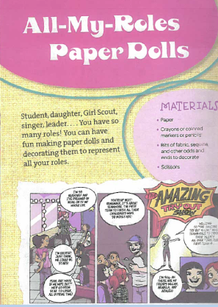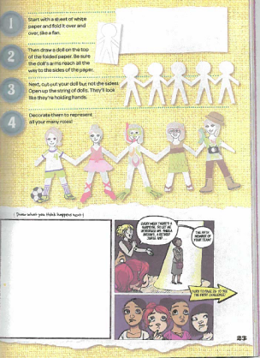
“Reach Out”
Page 10
Canvas Art (make from magazine pics – find stereotype busting topics). Purchased canvas from Michaels. Paint in advance and let dry.
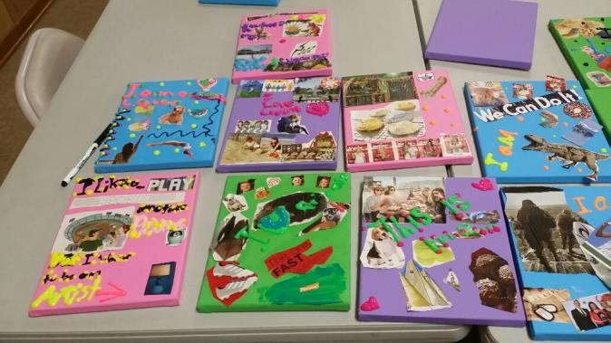
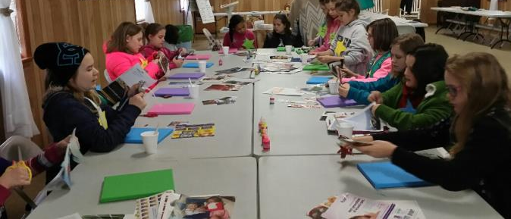

“Speak Out”
Page 11
Breathing Exercise (Relax) before telling your story:
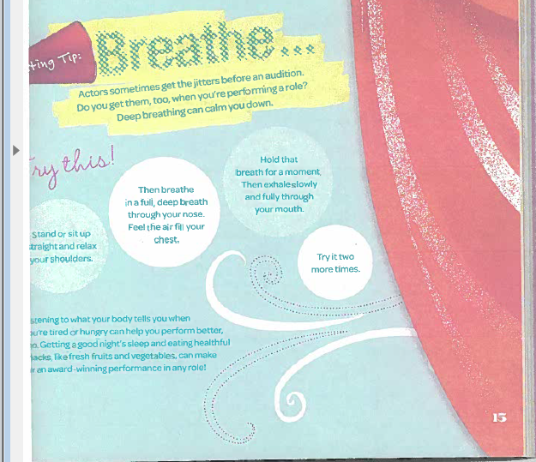
(Page 15 – Girl’s Book)

“Speak Out”
Also use Story Cards or Story Rocks (Great Story Telling Activity)
These stories are to be Stereotype Busters

Page 12

“Speak Out”
Storytelling Skills (Sterotype Busters as topics )
“A Good Yarn"

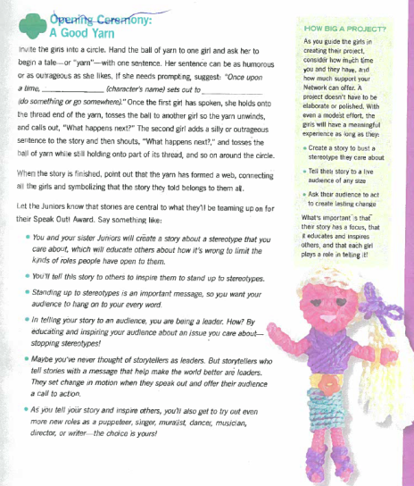
Page 57 in Girl’s Book

Page 13
“Speak Out”
Role Playing (page 32 Girl’s Book)
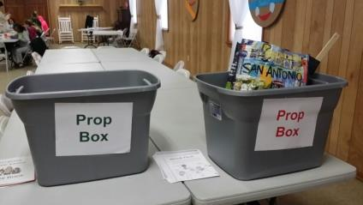
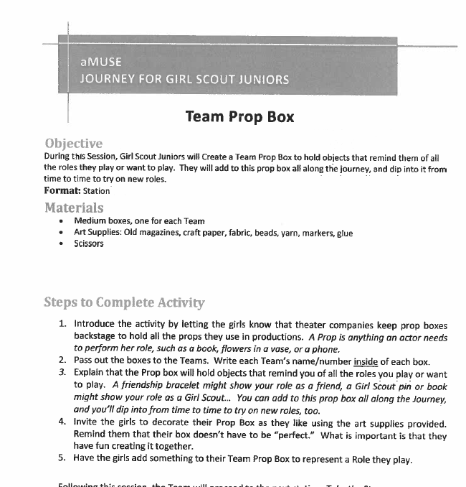

Page 14

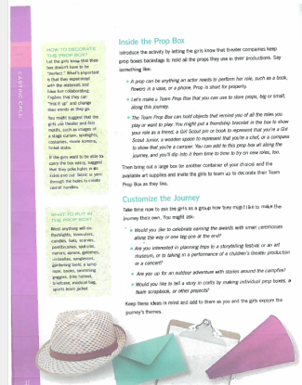
Page 32 Girl’s Book

“Try Out”
Practice Stereotype busting story to perform in front of full group. Performance will be the “take action” project. Practice Stereotype busting story to perform in front of full group. Performance will be the “take action” project.

