COOKIES
For
Cops
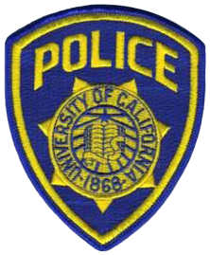

Save the Date: Nov 21, 2018

This is an annual Marsh of Glynn Service Unit event. Cookies, brownies, etc. are baked (or bought), sealed in a plastic baggies, and then placed in a decorate paper bag with the designated officer’s name. Cookie bags are delivered to the officers on the Wednesday before Thanksgiving (November 21st, 2018) at the designated locations. More information and Officers names to come at the October & November SUM.

For any further information, please contact Ms. Deborah Coleman @ (912)258-2359.

