Looking for
Babysitters

“Bee” a Great Sitter:
- “Bee” a Cadette, Senior or Ambassador
- “Bee” a trained Program Aide
- “Bee” able to get to/from meeting sites
- “Bee” prompt and arrive 15 minutes prior to meeting time.
- “Bee” fun! Enjoy working with children of all ages.
- “Bee” organized and ready at all times with an activity, game or song.
- “Bee” able to monitor the group for a safe, fun and learning environment.

“Bee” a great sitter and sign-up!
We will need 2 per meeting.
New”bee”s will be paired with older girls.
$7 per hour

Interested in “bee”ing a Babysitter?
- Fill out the information sheet.
- Sign the guidelines agreement.
- Keep one copy of the agreement.
- Wait to hear from Mrs. Melba Williams.
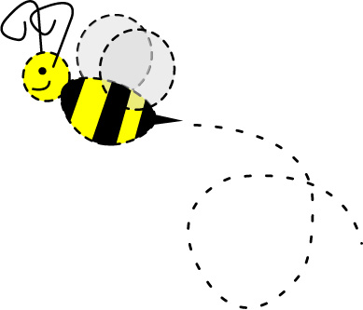
- You can also text 269-2308 with any questions.

Marshes of Glynn Babysitting Guidelines
2016-2017
GENERAL RULES TO FOLLOW
- Parent/Guardian of all children need to sign their child in and out. A sign in sheet will be provided.
- Keep an eye on the children – interact with them – play games, sing songs, color, etc.
- Never leave the children unattended
- Do not invite friends to come and visit with you while babysitting.
- Do not allow the child to leave and go find Parent/Guardian. If the child gets sick/hurt, follow Step #8.
- Do not sit and use cell phone, IPODS, electronic gadgets during babysitting time
- Absolutely No texting!!!
- Only exception to using the phone is to:
  - Call for help concerning a sick/hurt child:
    - 912-269-2308 (Melba Williams)
    - Quietly get the mother out of class if needed.
  - Adult will call 911 if necessary
- First Aid kit will be provided – should you need to use a band aid, etc, please make a note of it on the sign in sheet in the “notes” column.
- Make sure the children have an enjoyable experience in your care!!

ST. JAMES LUTHERAN CHURCH
- The children may NOT have food in the nursery.
- If they bring food or drink, they may eat/drink in the narthex outside the nursery room but not IN it. And any crumbs or spills need to be cleaned up. (There is no cleaning service to check/clean the church before Sunday so we need to leave it in great condition.)
- Also – for everyone (includes adults) we’ll make sure the paper towels are in place and the toilet paper refilled on the spools as needed in the restrooms. Wipe the counters dry and floor if it is wet.
- Make sure the toys in the nursery are put up neatly.
- GOLDEN ISLES ELEMENTARY
- No eating is allowed in the Gym
- Be careful with the mats – ok to use, but put them back in their proper place before leaving.

Pay = $7.00 per hour
I promise to “bee” a great sitter and follow the rules:____________________________ Date___________
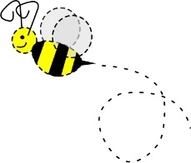
“Bee” a Great Sitter!

Important Information
Sitter’s Name_______________________________________________________________

Email Address_______________________________________________________
This email “bee”longs to______________________________________________________________

My Phone Number_______________ Is this phone a home or cell #?____________
May we text you?________

Facebook name____________________________
Is this you or a parent?_________________
If you did not list a parent above for a Facebook name, please do so here_______________________

Emergency Name ________________________________ Number__________
Have you been a babysitter before for the Service Unit?_________________

