Camp Low
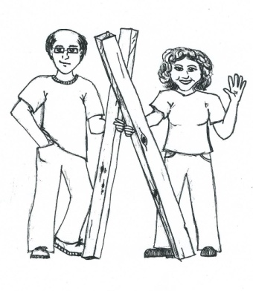
Adopt-a-Camp Team (A.C.T.)

If I had a Hammer…
I’d hammer in the morning..
I’d hammer in the evening..
All over Camp Low!

One Weekend Works Wonders

Addicted to HGTV Makeovers?
Don’t just watch…. DO!
Come share in that feeling by helping restore beautiful Camp Low.
Recruiting: Skilled & Work-ready hands of parents, grandparents, friends,
& willing Girl Scouts (12 & older)

Volunteer Work Weekends: 8 am Saturdays through 3 pm Sundays. Give a half a day or the whole weekend. Free Accommodations will be available with pre-registration.

Individuals welcome or Get a Troop or Group together and Adopt a building or part of camp.

November 5-6, 2022
January 14-15, 2023
March 4-5, 2023
May 6, 2023
September 16, 2022

There is always lots of cleaning and general improvements that need attention, plus more skilled jobs in electrical, plumbing, carpentry, & masonry tasks. There will be Jobs for all skills and at all levels.

If you have these, please bring:
Hammer, rake, gloves, safety goggles, tools of your trade, some type of food item that can be shared with others for lunch and/or breakfast (this can be a bag of chips, loaf of bread, pack of lunch meat, or whatever.) Saturday supper provided (with prior notification that you will be with us.)
THREE ways you can help:
- Donate to the Camp Low Buy-a-Board Campaign (More info- contact Margaret Laurens)
- Have your troop Adopt a part of Camp Low (contact Diana McDaniel)
- Help &/or recruit skilled adults or willing girls to help restore camp (Volunteer Challenge - contact Laura Pittman)

Detailed information & Registration forms available on gshg.org
(search " Adopt-a-Camp " & select "Camp Work Day Volunteer Information Form")

Contact: Laura Pittman stelaupit@gmail.com
Margaret Laurens jcharles195@comcast.net
Diana McDaniel Dcmcdan@georgiasouthern.edu
Lynda Houghton, lyndah53@yahoo.com

PLEASE PASS THIS INFORMATION TO SKILLED FRIENDS & FAMILY

