Sew What?
A Pathway for those who want to sew

This Pathway is an opportunity for older girls (and adult helpers) to learn a valuable life skill, help others, get comfortable with a machine, and be wonderfully creative with a sewing machine.

Cadettes, Seniors, & Ambassadors will meet at Emanuel Methodist Church usually on the 4th Saturday of each month (with some exceptions) from 9:00 am till 1:00 pm. Cost will be $10 for the entire Pathway. Bring your lunch. Most fabric will be provided, but participants can bring some too if they want. Maximum of 14 participants. Adult helpers welcome, even if you can’t sew-- you’ll learn too!

At present I have 7 sewing machines available, and might can get more, but participants can bring their personal machine if it works. (IF IT NEEDS A TUNE-UP LET ME KNOW AHEAD OF TIME, & I might can help get it ready.)

Tentative dates and sessions:

September 24- THE BASICS:
- There are different threads & needles, when to use each and why
- Threading a machine
- Simple maintenance
- Cutting out simple bags
- Sewing bags for the GSHG Council goal for the homeless

November 19- SEW ON YOUR GIRL SCOUT PATCHES & MORE BAGS
- Bring your GS uniform vest or sash and finally sew on those badges (not just stapled or glued)
- More bags for GSHG project

January 28, 2023- START DESIGNING YOUR RENAISSANCE DRESS (& MORE BAGS)
- Start designing your Renaissance dress (some Fabric & trimmings available or furnish your own)
- Learn techniques for fitting and cutting out patterns (during the 4 hour session, you will sign up for a time for YOUR fitting and pattern layout, etc)
- Begin cutting your dress out
- Work on more bags during your wait-your- turn time

February 25, 2023- WORK ON YOUR RENAISSANCE DRESS (& MORE BAGS)
- Work on assembling the main pieces of your Renaissance dress
- Work on more bags during your wait-your- turn time
- Start working on accessories and/or extra components for your costume during your wait-your-turn time

March 25, 2023 FINISH YOUR RENAISSANCE DRESS (& MORE BAGS)
- Complete your Renaissance dress
- Complete accessories and/or extra components for your costume while you wait-your- turn
- Work on more bags during your wait-your- turn time

April 22, 2023 Trip to THE RENAISSANCE FAIRE in costume (Fairburn, GA)
(this could be an overnight trip, but that will be determined by the group) Individuals cover cost of entry ticket and travel arrangements. To be discussed when more data available
Go to https://www.garenfest.com for information about the Renaissance Festival. It’s fun!

PLEASE NOTE: Each session will require a large amount of set up and clean up, so YOU CANNOT miss the first session, and you need to BE ON TIME. I know there might be exceptions, BUT as a rule this will be EXTREMELY RARE. I cannot do makeup sessions, and the class will not wait for you.

Register with Laura Pittman at stelaupit@gmail.com, or 912-617-6394 no later than September 16. MAXIMUM of 14, minimum of 6, and first sign-up basis. Pay on arrival on Sept 24.
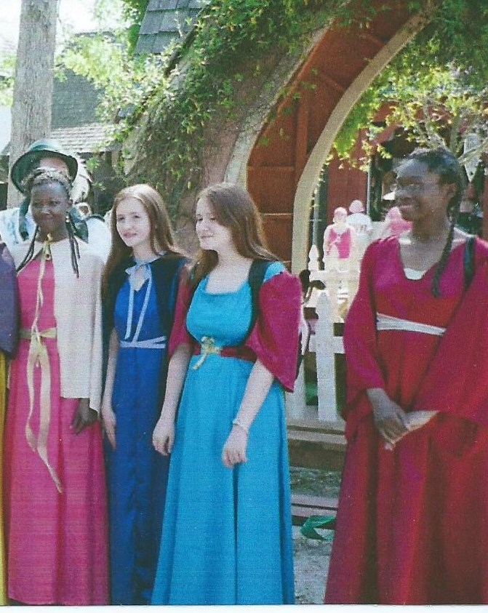
Ac
Actual costumes made by my troop several years ago. Girl Scouts are standing with the king and queen of the Faire. (And NO, you don’t have to go in costume, but it’s much more fun.) What goes on at a Renaissance Festival?

